“CARE WEBSITE”

DEVELOPER GUIDE

|  |  |  |
| --- | --- | --- |
| **Supervisor:** | MUHAMMAD HARIS |  |
| **Batch:** | 2405G2 |  |
| **Group:** | B |  |
| **Serial no.** | **Enrollment number** | **Student Name** |
| 1. | 1552011 | Muhammad Bin Adeel |
| 2. | 1572866 | Muhammad Huzaifa |
| 3. | 1571601 | Muhammad Khizar |
| 4. | 1572862 | Muhammad Arbaz |



Home 

Code Of Home Page

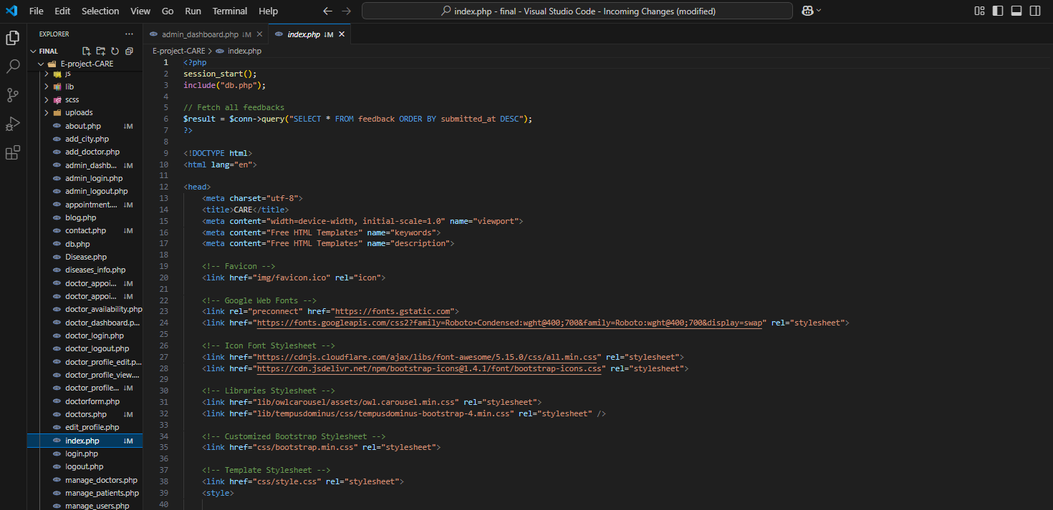

(HOME: ABOUT US):

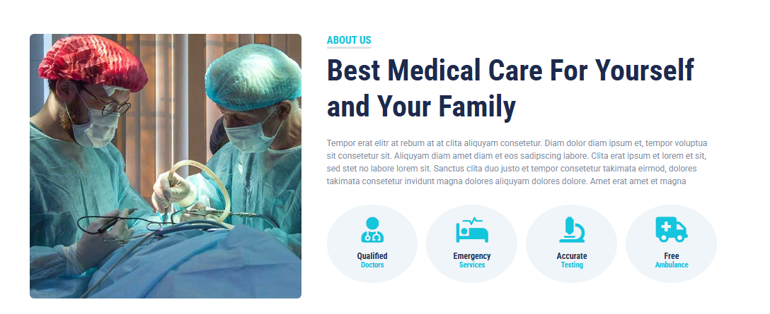

CODE OF ABOUT US

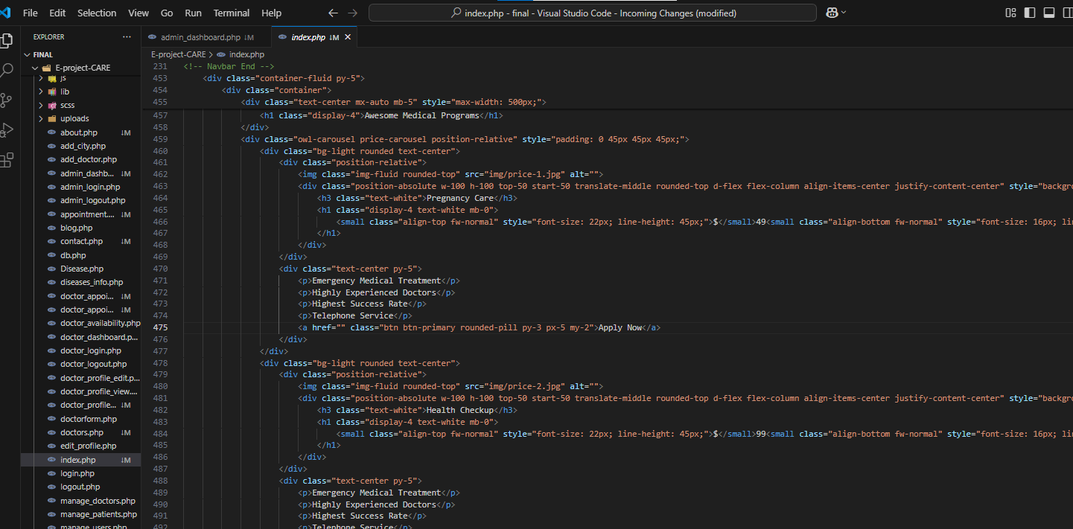

Doctor (Pannel):

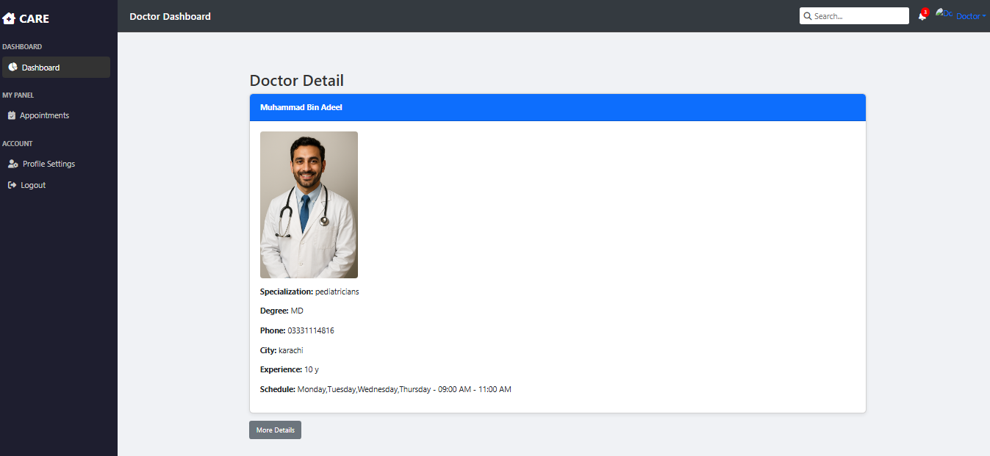

CODE OF DOCTOR PANNEL

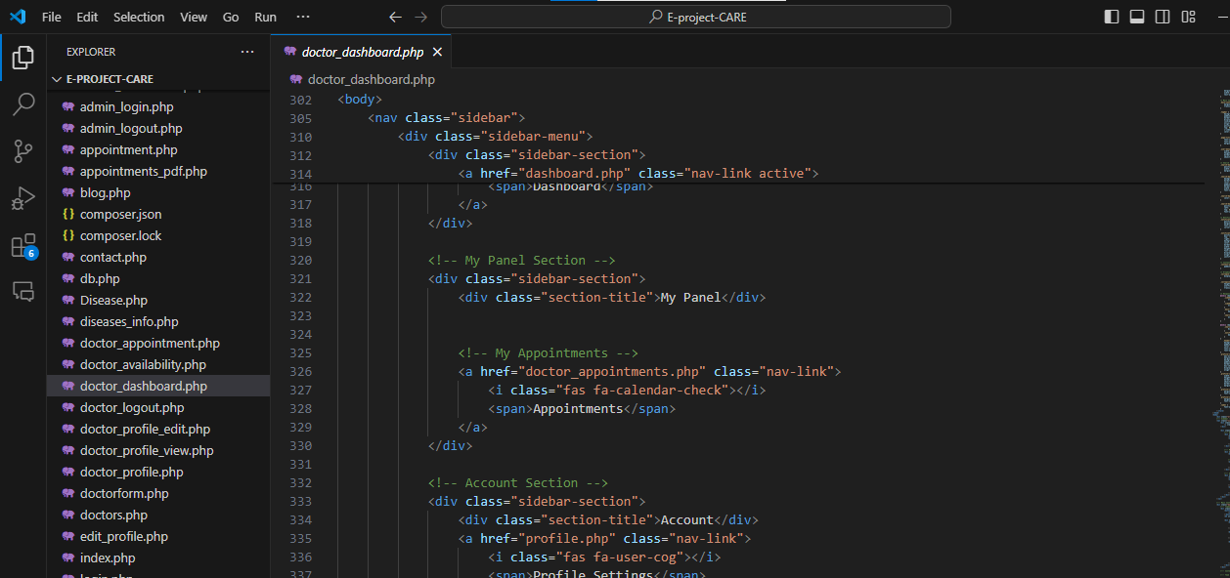

(APPOINTMENT.PHP)

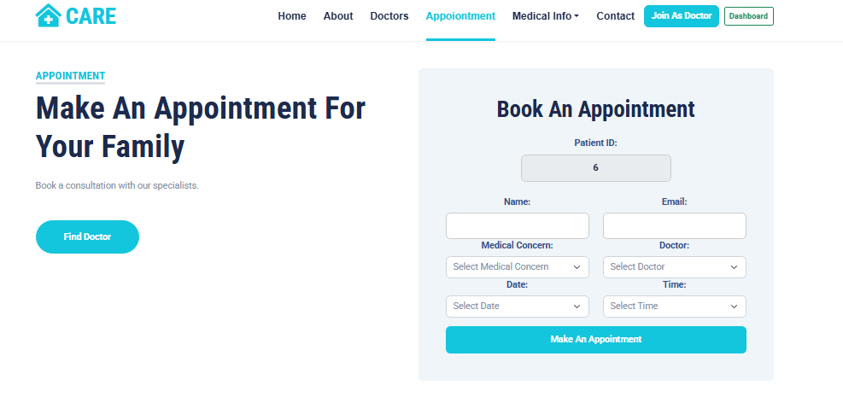

CODE OF APPOINTMENT

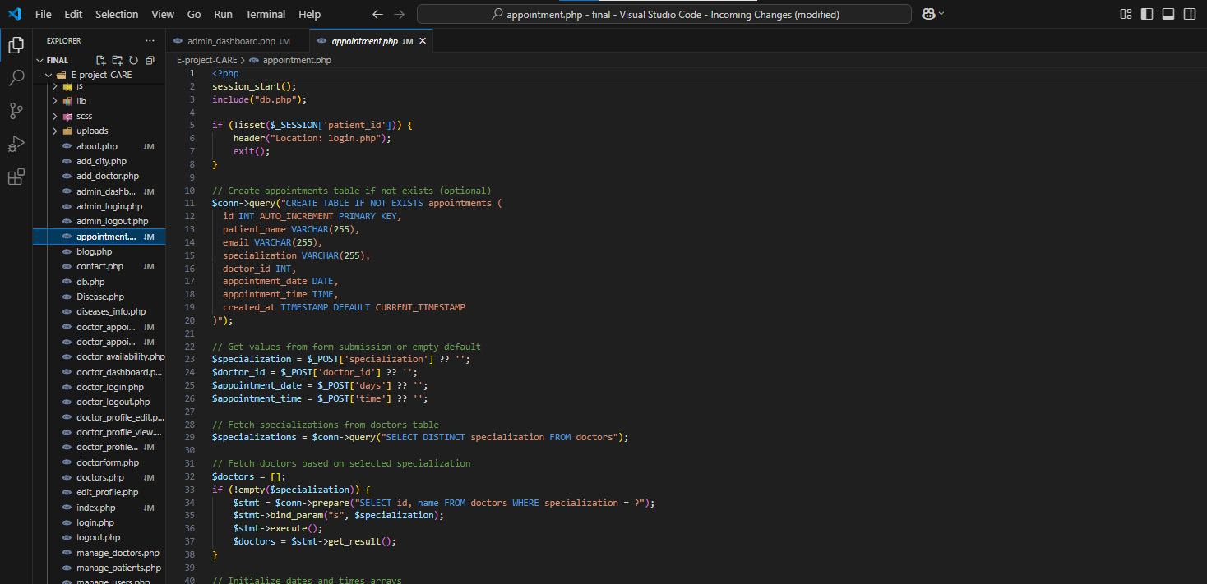

OUR DOCTOR:

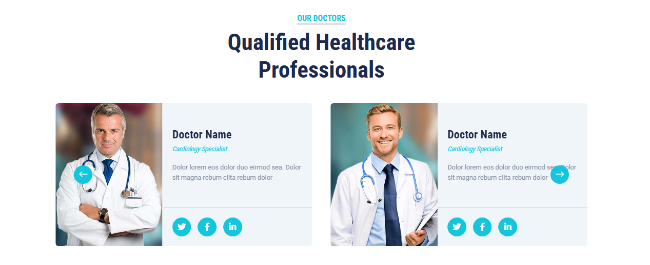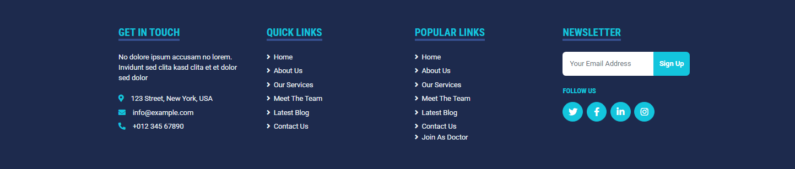

CODE OF DOCTOR

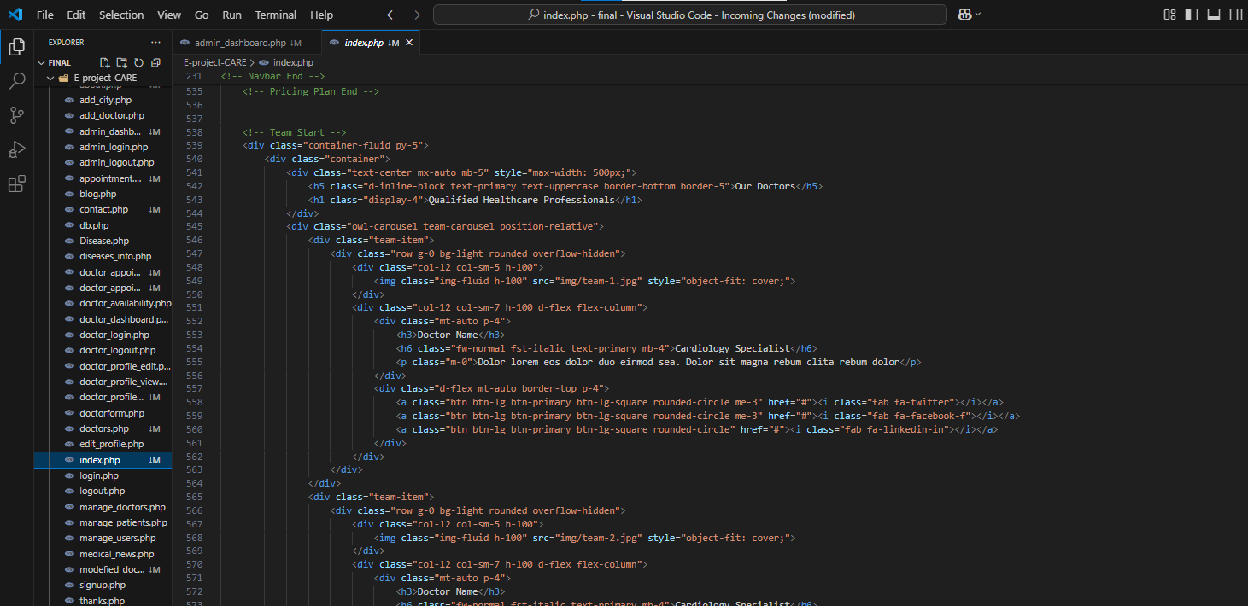

CONTACT:

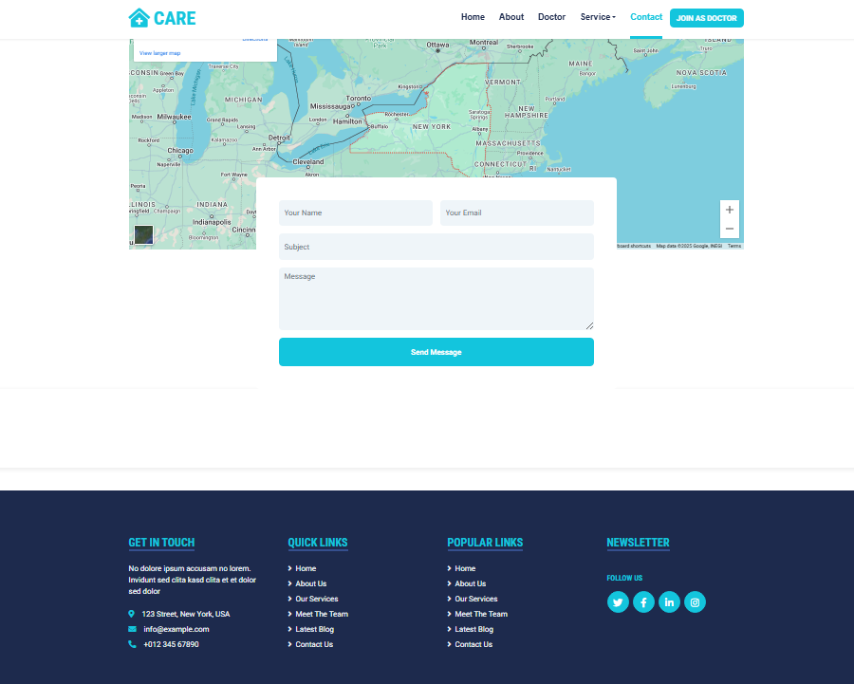

CODE OFCONTACT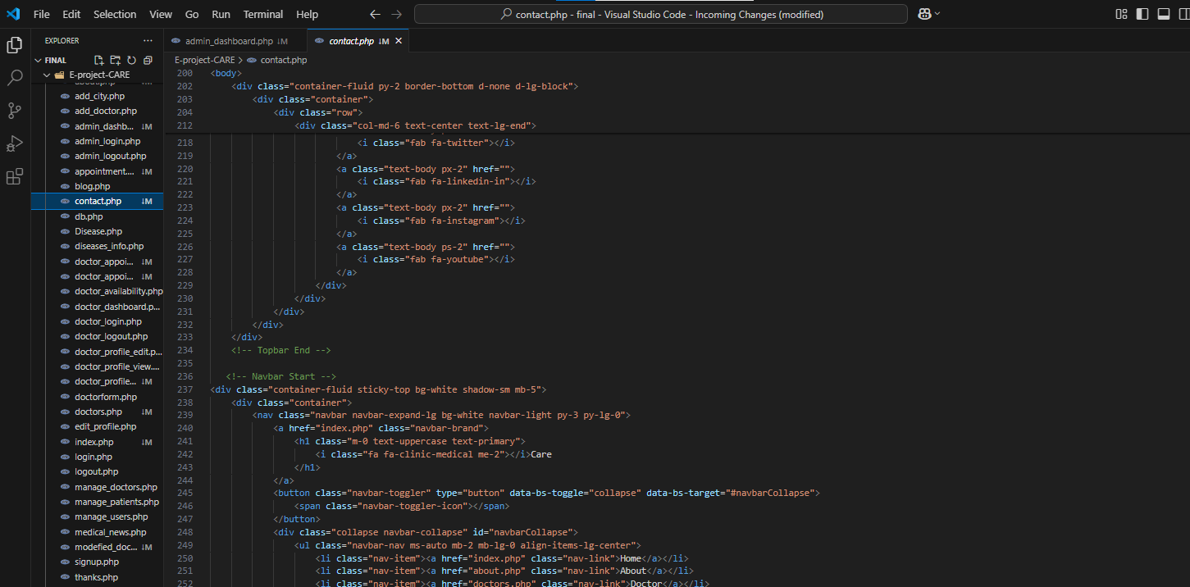

Admin (Pannel):

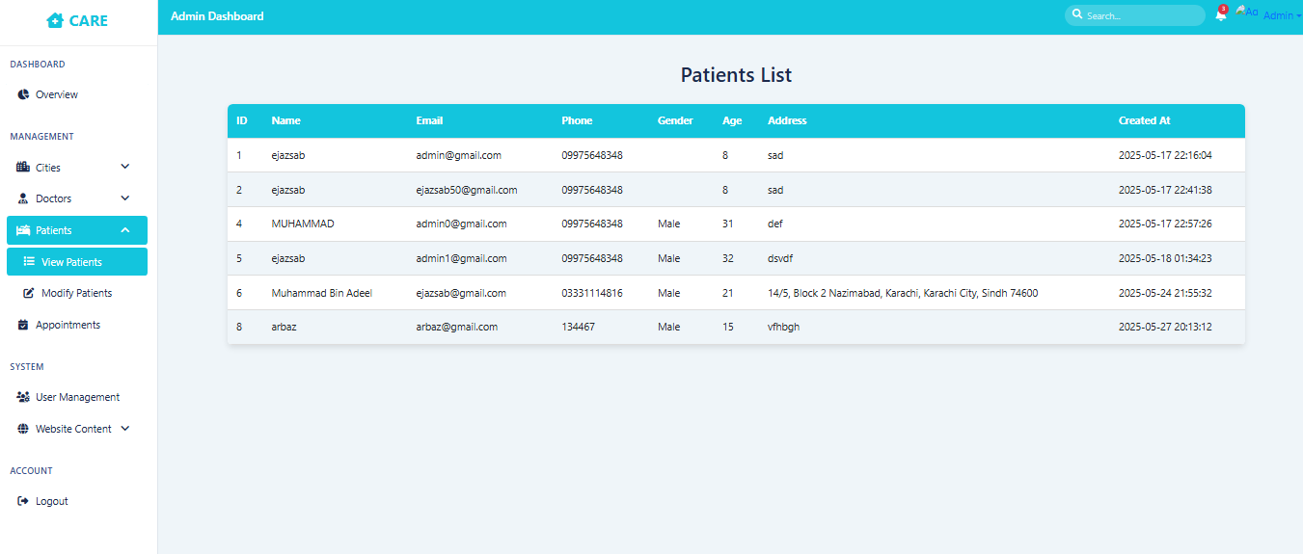

CODE OF ADMIN PANNEL



DOCTOR (FORM):

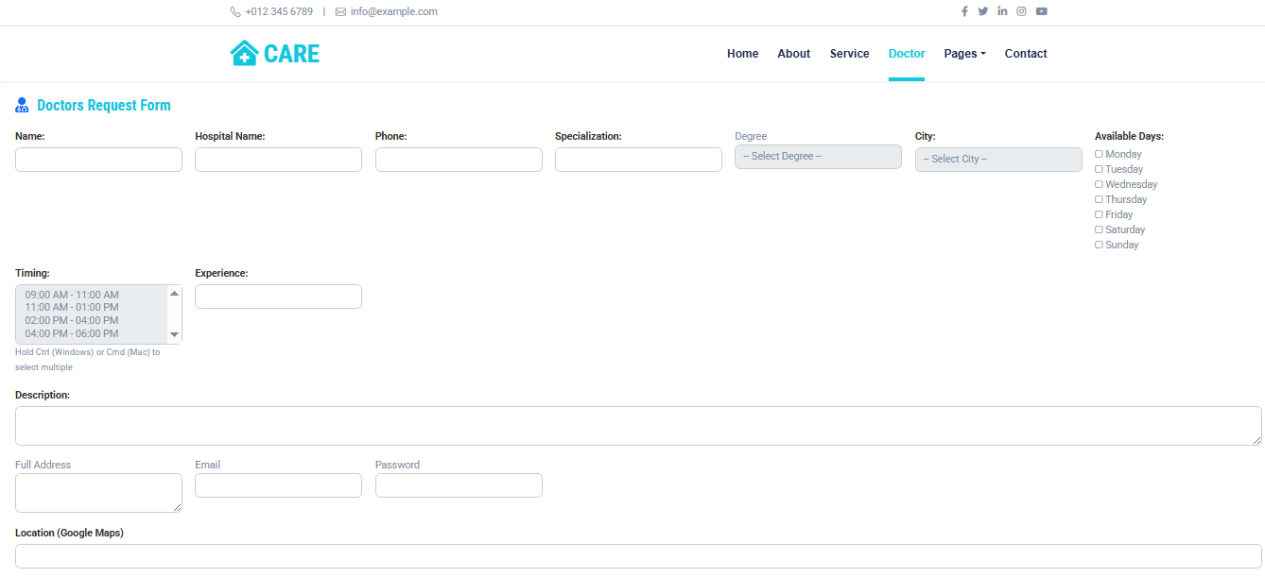  
CODE :DOCTOR (FORM):

